GRAPHICAL ABSTRACT
Title: Cxxxxxx Trxxxxt Axxxx of Dixxxx InAs/GaAs Qssss Dosssst Structures
Authors: Hsss Hsss Sorrr, Jxxx Sxxx Kim, Xx Kxx Kim, Sxx Jxx Lee, and Sxx Kxx Nxx

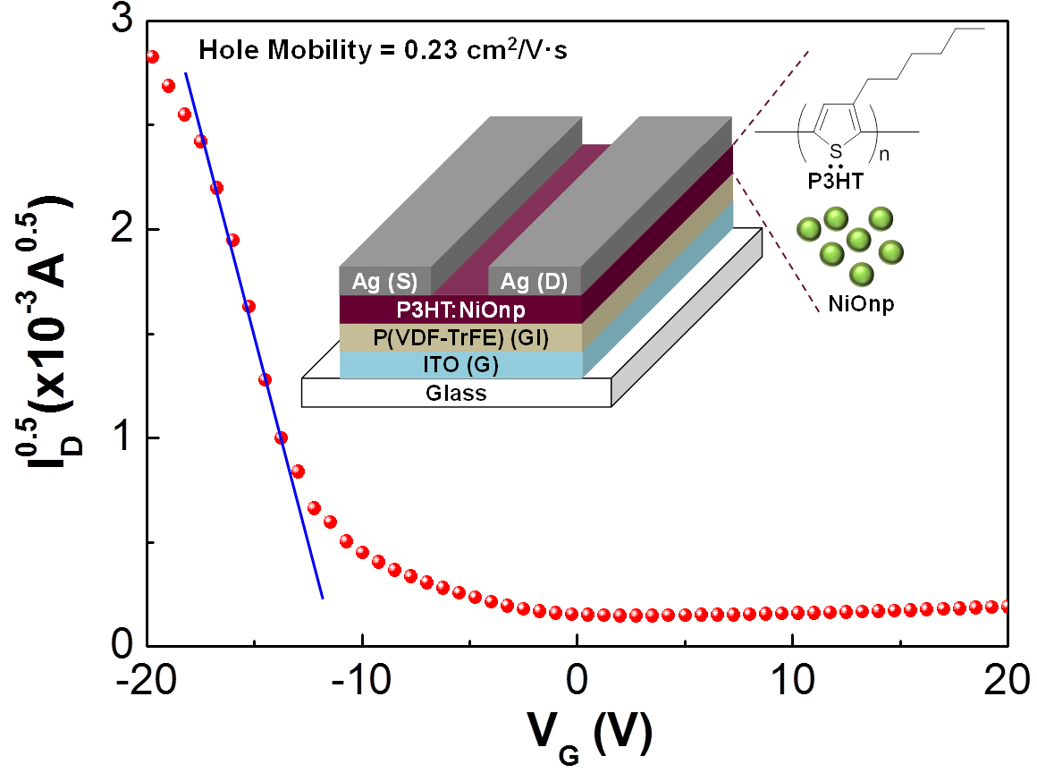
The energy states of InAs/GaAs self-assembled quantum dots (QDs) were analyzed by comparing between two QD systems with different QD sizes. The electrical properties of the QD systems were investigated via capacitance-voltage measurements and capacitance transient spectroscopy (also known as deep-level transient spectroscopy) with selective carrier injection and extraction, which can be achieved with a very small pulse amplitude under bias variation. The comparison of the large QD structure with the small one was particularly focused on.

